
Name:
Teacher:
YEAR 11 SEMESTER ONE 2006

HUMAN BIOLOGY EXAMINATION

SECTION B

Section A: Multiple Choice – 40 Questions – 40%
Answer the multiple choice questions by CROSSING out the letter of your choice on the answer sheet provided.

Section B: Short Answers – 10 Questions – 40%
Answer the questions in the spaces provided. Answers are to be in BLUE or BLACK biro.

Section C: Extended Answers – 2 Questions – 20%
Answer all parts of question 1 or 2 and all parts of question 3 or 4. Write the answer on the lined paper provided.
Section A = / 40

Section B = / 127 X 0.315 = /40

Section C = /20

Total /100

SECTION B: - Short Answer

You must answer all the questions in Section B in the spaces provided. Answers must be in BLUE or BLACK PEN, diagrams are to be in pencil and clearly labelled.

Question 41

(a) Describe how the following factors affect the rate of diffusion?

Concentration of Molecules
_________________________________________________________________________
_________________________________________________________________________
_________________________________________________________________________
_________________________________________________________________________
Temperature
_________________________________________________________________________
_________________________________________________________________________
_________________________________________________________________________
_________________________________________________________________________
(2)

(b) What are the differences between aerobic and anaerobic respiration?
Aerobic Respiration _________________________________________________________________________
_________________________________________________________________________
_________________________________________________________________________
_________________________________________________________________________
_________________________________________________________________________

Anaerobic Respiration
_________________________________________________________________________
_________________________________________________________________________
_________________________________________________________________________
_________________________________________________________________________
_________________________________________________________________________
(2)

- Identify the organelles labelled from the following diagrams and write a major function for each of them below.

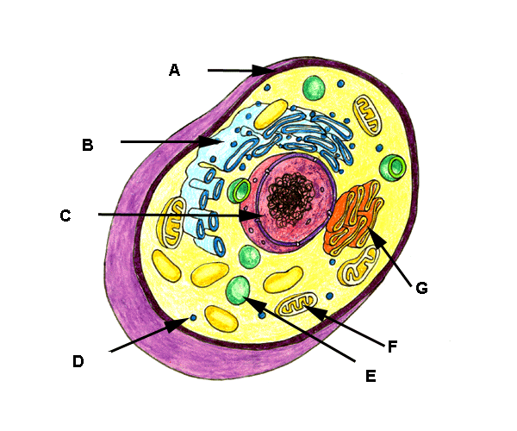

 | STRUCTURE | FUNCTION
A
B
C
F
G

(5)
(d) Complete this equation.

C₆ H₁₂O₆ + ___________________ 6CO₂ + 6H₂0 + _____________
(2)

(e) Which type of respiration is represented by this equation?
_________________________________________________________________________

(f) In which part of the cell does the equation in (d) take place? (1)

_________________________________________________________________________

(g) Give one use for the ATP. (1)
___________________________________________________________________________

___________________________________________________________________________
(1)

(h) For each of the processes below. State which organelles or structures are associated with that process.

Secretion
Cellular Respiration
Pinocytosis
Phagocytosis
Protein Synthesis
Cell Division

(6)

Question 42.
- Label the diagram of the heart in the table provided.

ANTERIOR VIEW OF LONGITUDINAL SECTION OF THE HEART
(5)

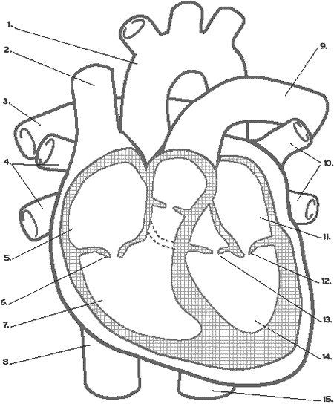
1
2
5
6
7
9
10
11
13
14

(b) Explain the functions of the following structures.
SEPTUM __________________________________________________________________
______________________________________________________________________________________________________________________________________________________

LEFT VENTRICLE__________________________________________________________
______________________________________________________________________________________________________________________________________________________

TRICUSPID VALVE ________________________________________________________
______________________________________________________________________________________________________________________________________________________
(3)

(c) On these smaller diagrams, show the passage through the heart of oxygenated blood on diagram A and deoxygenated blood on Diagram B.
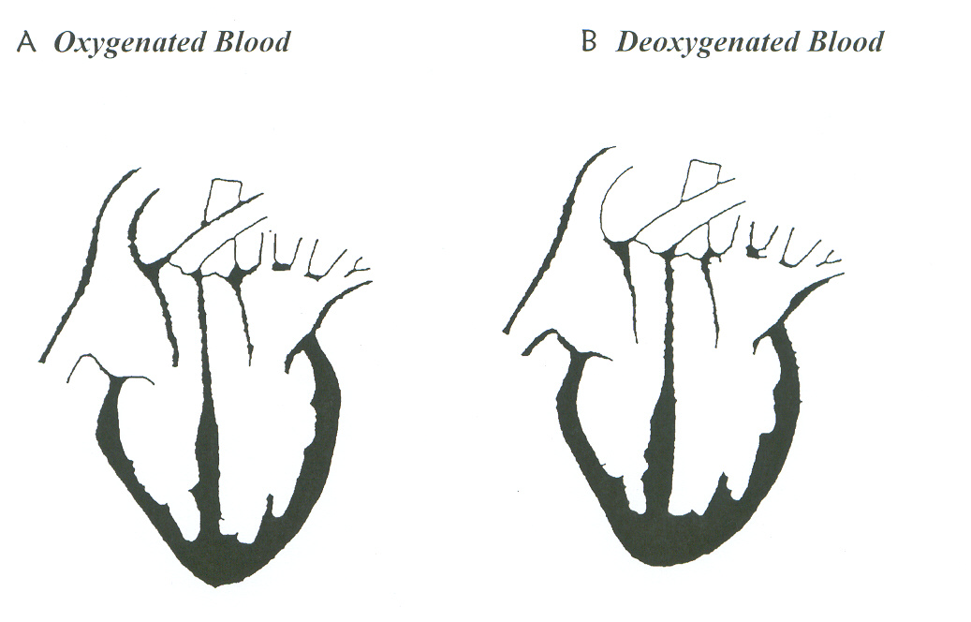
(4)
(d) Explain systolic and diastolic blood pressure in terms of what is happening in the heart.
___________________________________________________________________________________________________________________________________________________________________________________________________________________________________________________
________________________________________________________________________________________________________________________________________________________________________________________________________________________________________________________________________________________________________________________________________________________________________________________________________________________________________________________________________________________________________________________________________________________________________________________________________________________________________________________________________
(4)
- What would happen if the chordae tendonae were severed or broken?
__________________________________________________________________________________________________________________________________________________________________ (1)
- What are the two major functions of the lymphatic system? (i)_________________________________________________________________________
(ii)________________________________________________________________________
(2)
- What is the name given to the medical condition caused when:

(i) there is a complete blockage in a coronary artery
___________________________________________________________________________
(ii) the heart ceases to act as a pump
___________________________________________________________________________
(2)

Question 43.
Refer to the diagram below:
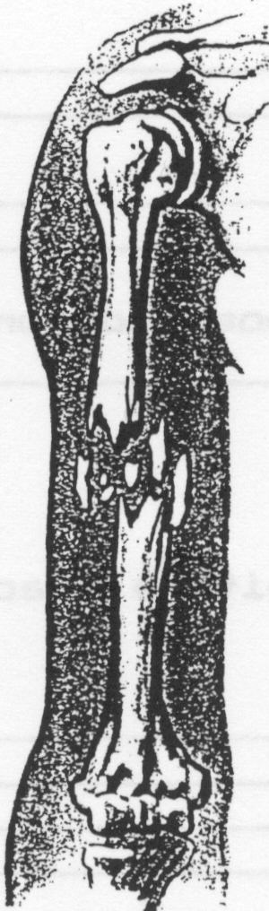

(a) Describe the type of fracture illustrated above. ____________________________
(1)
(b) List four main signs and symptoms which may indicate that a fracture has occurred.
_____________________________________________________________________________
_____________________________________________________________________________
_____________________________________________________________________________
_____________________________________________________________________________
_____________________________________________________________________________
_____________________________________________________________________________
(4)
(c) Why must a fracture be immobilised before moving the casualty?
_____________________________________________________________________________
_____________________________________________________________________________
_____________________________________________________________________________
_____________________________________________________________________________
(2)

Question 44.
FIGURE 1 – Skeleton and skeletal features of a quadruped primate, gorilla and human.
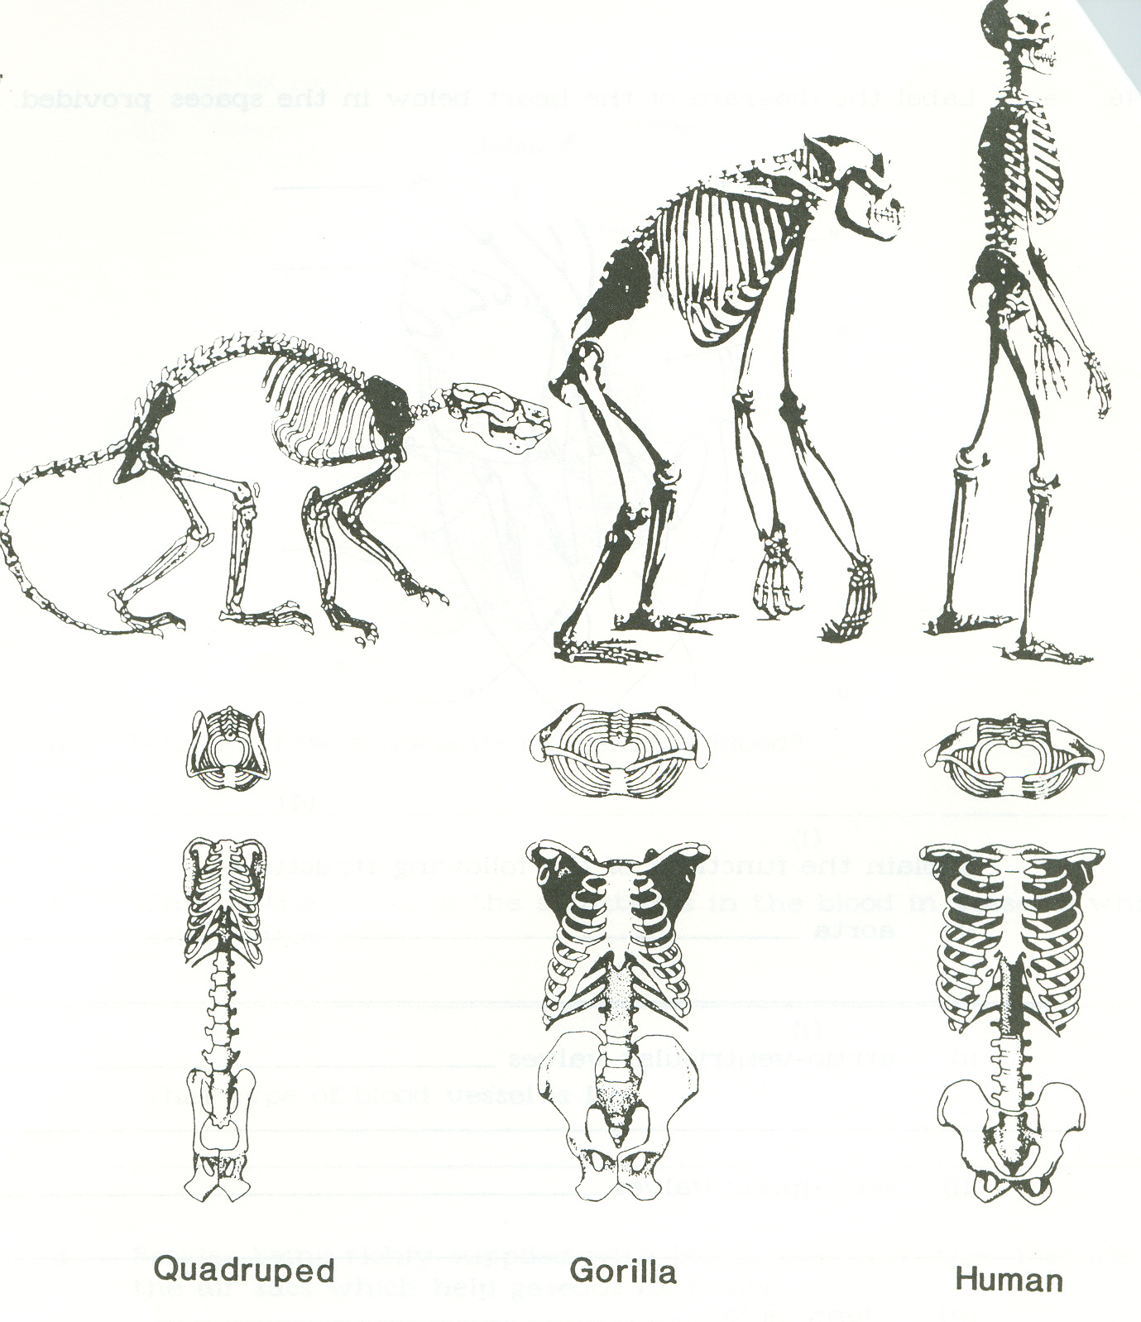
Examine the illustrations of the full skeleton and skeletal features belonging to a quadrupedal primate, gorilla and human in Figure 1 above.

(a) State ONE feature of the quadrupedal skeleton illustrated in Figure 1 which is suited for quadrupedal walking and explain how it assists this mode of locomotion.

____________________________________________________________________________________________________________________________________________________________________________________________________________________________________________________________________________________________________________________________________
(2)

(b) Describe TWO structural features evident in Figure 1 which account for the fact that the gorilla is not able to walk bipedally for extended periods of time.

(i)_________________________________________________________________________________________________________________________________________________________________________________________________________________________________________________

(ii)_________________________________________________________________________________________________________________________________________________________________________________________________________________________________________________
(4)

(c) Describe TWO structural features evident in Figure 1 which enable humans to carry out bipedalism.

(i)_________________________________________________________________________________________________________________________________________________________________________________________________________________________________________________

(ii)_________________________________________________________________________________________________________________________________________________________________________________________________________________________________________________
(4)

FIGURE 2 – PRIMATE HANDS

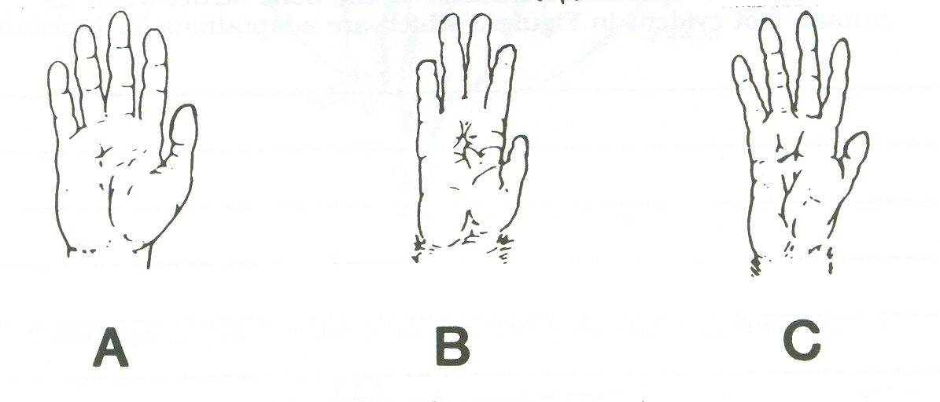

(d) Which of the hands illustrated in Figure 2 is not suited for brachiation? Explain why. Give three reasons.

_____________________________________________________________________________________________________________________________________________________________________________________________________________________________________________________________________________________________________________________________________________________________________________________________________________________
_____________________________________________________________________________________________________________________________________________________________________________________________________________________________________________________________________________________________________________________________________________________________________________________________________________________
(4)

Question 45.

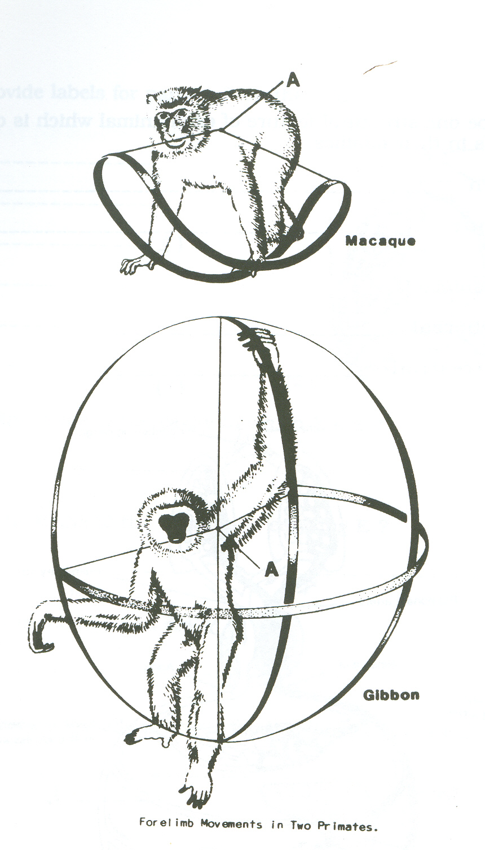

(a) What type of joint is the joint labelled A on the diagram above?

__________________________________________________________________________
(1)
(b) Both of these animals belong to the same sub-order. What is it?

__________________________________________________________________________
(1)

(c) Give the family name for each animal.
Gibbon____________________________________________________________________

Macaque___________________________________________________________________

(2)

(d) Describe one feature of each animal which is common to all animals in their families.
Gibbon____________________________________________________________________
______________________________________________________________________________________________________________________________________________________
Macaque___________________________________________________________________
______________________________________________________________________________________________________________________________________________________
(2)
(e) Which animal is: arboreal___________________________________________________________________

terrestrial__________________________________________________________________

(2)

Question 46.

SUBSTANCE | CELL | SOLUTION 1  (mg/mL) | SOLUTION 2  (mg/mL)
Sodium | 70.0 | 30.0 | 100.0
Magnesium | 0.003 | 0.005 | 0.001
Potassium | 420.0 | 400.0 | 500.0
Calcium | 1.2 | 0.6 | 10.0
Chlorine | 510.0 | 600.0 | 100.0
Total | 1001.203 | 1030.205 | 710.001

(a) If the cell was placed in solution 1, describe the nett movement of water and explain why this would occur?
________________________________________________________________________________
________________________________________________________________________________
________________________________________________________________________________
(2)

(b) If the cell was placed in solution 2, describe the nett movement of water and explain why this would occur?
________________________________________________________________________________
________________________________________________________________________________
________________________________________________________________________________
(2)

(c) If the cell was placed in solution 1, describe the nett movement of Sodium and explain why this would occur?
________________________________________________________________________________
________________________________________________________________________________
________________________________________________________________________________
(2)

(d) If the cell was placed in solution 2, describe the nett movement of Sodium and explain why this would occur?
________________________________________________________________________________
________________________________________________________________________________
________________________________________________________________________________
(2)

(e) When the cell was placed in solution 2, its chlorine level remained constant at 510.0mg/mL. Assuming that the cell membrane was permeable to chlorine, describe in detail how the cell achieved this.
________________________________________________________________________________
________________________________________________________________________________
________________________________________________________________________________
(2)
Question 47.

Below is a diagram of a small part of the circulatory system.

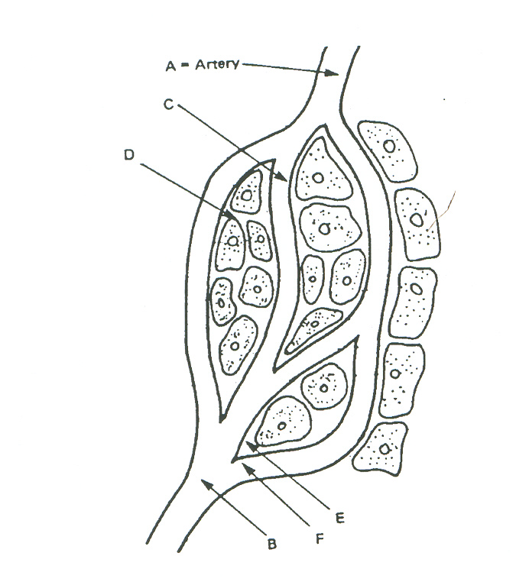

(a) Name the kind of vessel found at B. (1)

________________________________________________________________________________

(b) State one difference between the wall of the vessel at B and the vessel at A. (1)

________________________________________________________________________________

- State one difference between the blood pressure at B and A. (1)

________________________________________________________________________________
________________________________________________________________________________

(d) Name the kind of vessel found at C. (1)

________________________________________________________________________________

(e) Describe the liquid part of blood. (2)

________________________________________________________________________________
________________________________________________________________________________

(f) Name the fluid found at E. (1)

________________________________________________________________________________

(g) Name two useful substances that pass from C to D. (2)

(i)_______________________________________________________________________

(ii)_______________________________________________________________________

(h) Name one component of the blood that would not normally pass from C to D. (1)

________________________________________________________________________________

(i) Give one reason why this component would not normally pass from C to D. (1)

________________________________________________________________________________
Question 48.

- Name the following tissue types and a specific location in the body where you would find each tissue.

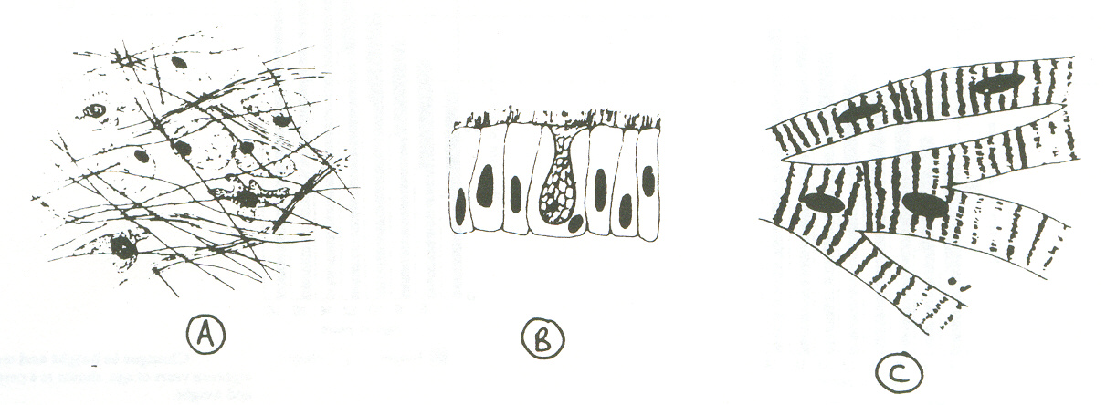
A
B
C
D
E
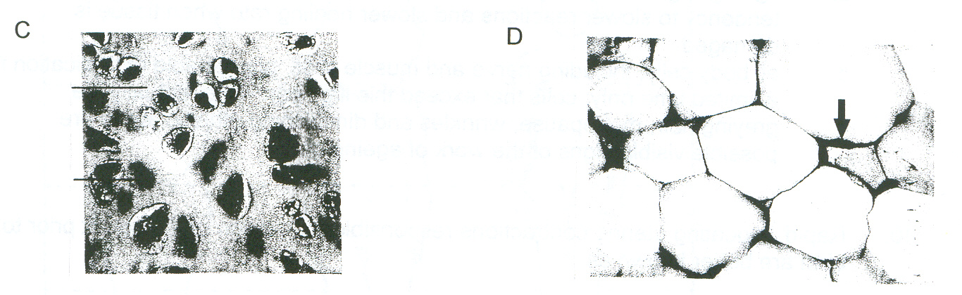

TISSUE | NAME SPECIFIC TISSUE | LOCATION FOUND IN BODY
A
B
C
D
E

(10)
(b) Complete the following:
(i) What is a ‘carcinogen’?

__________________________________________________________________________________________________________________________________________________________________
(ii) Name two carcinogenic agents (1)

__________________________________________________________________________________________________________________________________________________________________
(2)
Question 49.

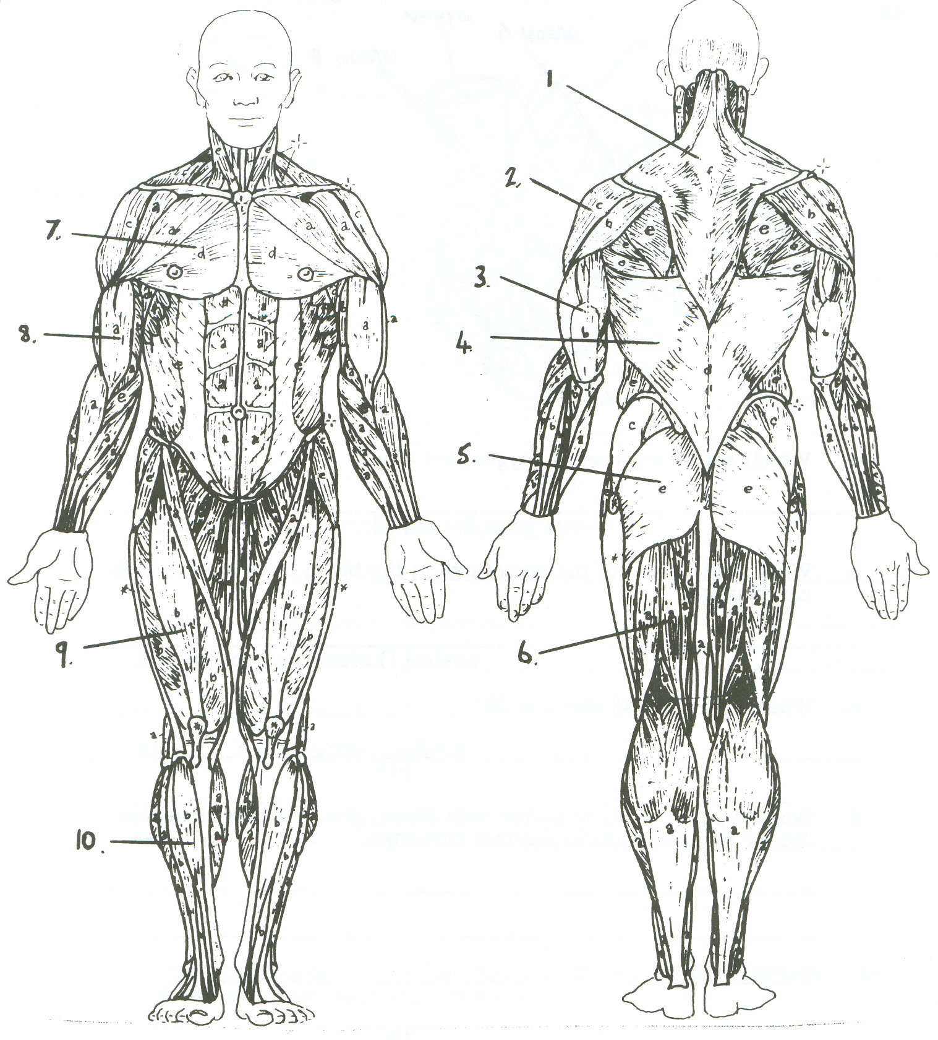

Label the following muscles from the diagram above.

Number | Muscle Name
2
5
6
9
10

(5)
Question 50.

(a) Identify the parts labelled A – H on the diagram below.

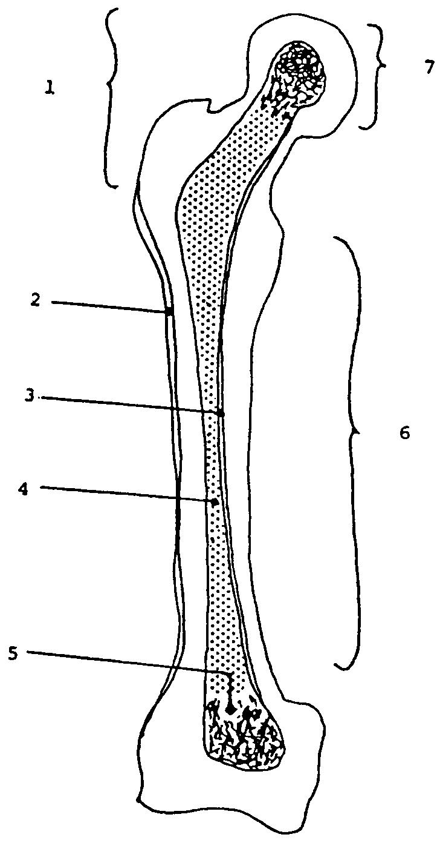

(1) _________________________________ (2) _________________________________
(3) _________________________________ (4) _________________________________
(5) _________________________________ (6) _________________________________
(7) _________________________________

Give the name of this bone in the human body? _________________________________
(4)
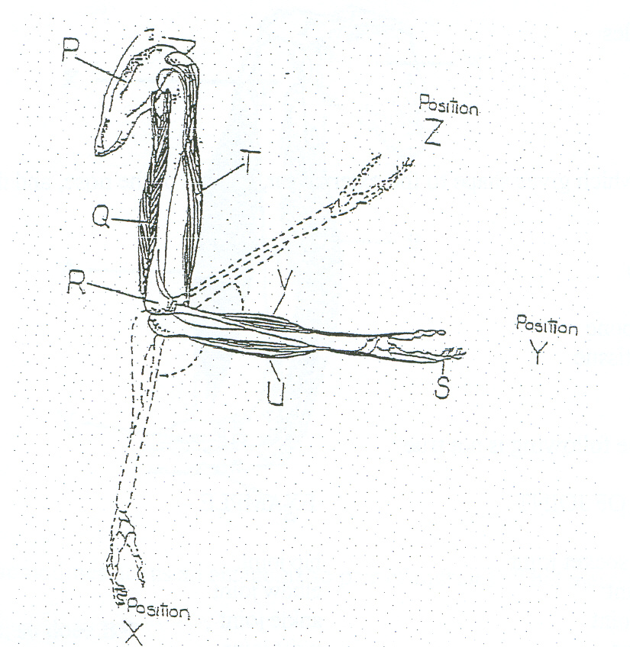

(b) Label the parts shown in the diagram above.

P _______________________________

Q _______________________________

R _______________________________

T _______________________________
(4)

(c) Complete the following table by drawing the joint and providing one example of where it is found in the body..

TYPE | DIAGRAM | EXAMPLE
GLIDING JOINT
SADDLE JOINT

(4)
(d) Describe how the knee is structure to cope with the range of movements and stresses required of it. Use a diagram to support your answer.

_______________________________________________________________________________
_______________________________________________________________________________
_______________________________________________________________________________
_______________________________________________________________________________
_______________________________________________________________________________
_______________________________________________________________________________
_______________________________________________________________________________
_______________________________________________________________________________
_______________________________________________________________________________
_______________________________________________________________________________
_______________________________________________________________________________
(3)

Question 51.

Draw the following diagrams to show their respective phases of Mitosis and give an explanation for each.
(3)
INTERPHASE

____________________________________________________________________________________________________________________________________________________________________________________________________________

METAPHASE
____________________________________________________________________________________________________________________________________________________________________________________________________________

____________________________________________________________________________________________________________________________________________________________________________________________________________
TELOPHASE

